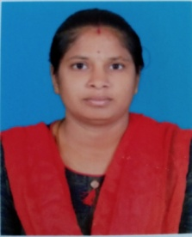

**STAFF PROFILE**

|  |  |  |
| --- | --- | --- |
| Name | : | **Mrs.B.MOHANAMBAL** |
| Designation | : | **Yoga Instructor** |
| Qualification | : | **B.Com.,PGDY** |
| Experience | : | **8 Months** |
| Educational Institute | : | **Annamalai University,Chithambaram** |